iwo Helper Desktop

USER MANUAL

Desktop tools for working with Excel and PDF documents

Program version – 1.18.0

2026
CONTENTS
1. About the program 5
1.1. What it is for 5
1.2. What the program gives you 6
1.3. What the workplace needs 6
1.4. Installing, starting and updating 7
2. How working with the program is arranged 8
2.1. The start screen 8
2.2. The language of the interface 10
2.3. The built-in help 11
2.4. The page grid 12
2.5. Viewing a page full size 14
2.6. Printing 15
2.7. Making the file smaller (compression) 15
2.8. Settings 17
2.9. Statistics 19
2.10. What happens to your files 19
3. Merge PDF 20
3.1. What it is for 20
3.2. The window 20
3.3. The order of work 21
3.4. Double-sided printing: “Add a blank page” 21
3.5. Assembling a double-sided scan 22
4. Split PDF 23
4.1. What it is for 23
4.2. The window 23
4.3. The modes of splitting 24
4.4. Naming the parts 27
4.5. Other operations on the open document 29
5. More operations 29
5.1. What it is for 29
5.2. The window 29
5.3. The actions 30
6. PDF → Word (beta) 32
6.1. What it is for 32
6.2. The window 33
6.3. The order of work 33
6.4. What comes across and what does not 34
7. PDF → PowerPoint (beta) 34
7.1. What it is for 34
7.2. How a slide is built 35
7.3. The window 35
7.4. The order of work 36
7.5. What comes across 37
7.6. What not to expect 37
8. Merge Excel 37
8.1. What it is for 37
8.2. The window 38
8.3. The order of work 39
8.4. The options 39
8.5. The result, the report and the cover note 39
8.6. The Menu of the tool 40
9. Reference 41
9.1. About the program 41
9.2. If something went wrong 42
9.3. A short reminder 43

1. About the program

1.1. What it is for
iwo Helper Desktop is a desktop program for everyday work with documents: it gathers the sheets of several Excel workbooks into one digest, merges and splits PDF files, makes them smaller, and turns the text of a PDF into an editable Word document or a PowerPoint presentation. Everything happens on your own computer; no file is sent anywhere.
The program is six tools, laid out on the start screen in two sections: five work with PDF, the sixth with Excel workbooks. Each does its own job and opens in its own window, so several can run at once: while one builds a digest, another can prepare a PDF.
Table 1 — The tools of the program
Tool | What it does | What for
Merge PDF | Builds one PDF out of several files, letting you pick the pages and their order | To hand over one set instead of a scattering of files, without distorting the originals
Split PDF | Extracts the pages you need, or cuts a document into parts: by ranges, every N pages, or by bookmarks | To take out of a thick document only what the recipient asked for
PDF → Word | Extracts the text and tables of a born-digital PDF into an editable .docx | To edit text rather than type it again
PDF → PowerPoint | Turns the pages of a born-digital PDF into a .pptx presentation: the text stays editable, everything else arrives as a background | To get back a presentation of which only the PDF is left
More operations | Six actions on a single document: compression, pages as images, text into .txt, grayscale, repair, document properties | To do to a finished file what would otherwise send you looking for a separate program
Merge Excel | Moves the sheets of several workbooks into one — a digest, with contents and a Word cover note | Not to open dozens of files by hand and copy the sheets one at a time

1.2. What the program gives you
The program assumes documents are working material, not something to experiment on. That leads to a few properties worth knowing in advance.
— Source files are never changed. No operation changes the source files. The result is always written to a new file and the original is left alone. Even if you try to save the result over the source, the program refuses and says so.
— One bad file does not ruin the run. A broken or password-protected file does not bring the work down: it is skipped, and the reason is shown in the list and in the report. The rest are processed.
— Long operations can be undone. A long operation can be stopped with the Cancel button, and no half-finished file is left on disk.
— The program remembers your habits. Every window remembers its size and position, the thumbnail zoom and the chosen compression level, so there is no need to set up your workplace again at each start.
— Mistakes are cheap. What the program does to the pages — order, rotation, removal — can be undone with Ctrl + Z, and redone with Ctrl + Y.

1.3. What the workplace needs
The program runs on Windows 8.1, 10 and 11, both 64-bit and 32-bit. No libraries need to be installed separately: everything needed is inside the program file.
Two capabilities need other products. The digest itself and its cover note are produced through the Microsoft Office installed on the computer, and the conversion of PDF into Word through Microsoft Word. Compressing a PDF, turning it to grayscale and repairing a damaged file are done by the free Ghostscript engine.

1.4. Installing, starting and updating
The program comes in two forms, and both are equal.
— Installer. An ordinary installation for the current user, without administrator rights. The compression engine is included and a Start-menu shortcut is created. The wizard begins by asking for a language, showing flags, and the program takes that language at its first start — including when installed over a previous version.
— Portable version. A single program file that only has to be copied and run. Suitable where installing anything is not possible.
The bitness follows the bitness of Windows: in the overwhelming majority of cases that is the 64-bit build; the 32-bit one is only for older systems.
The program looks for a newer version itself at start — quietly, in the background, and it says nothing about anything except news: no connection, no answer or “you have the latest” all pass without a word. When a version really is newer, the program names it and asks whether to open the download page in a browser. Nothing is downloaded or installed by itself — the decision stays with you. The check can be switched off in Settings, where there is also a “Check now” button.
Note. The program runs as a single instance. Starting the shortcut again does not open a second application but brings the running one to the front — which rules out two windows editing the same document.

2. How working with the program is arranged

2.1. The start screen
The start screen opens when the program starts. It asks first about the section (fig. 1): “PDF” — everything done to *.pdf files, and “Other tools” — the rest. Under the name of each section is a list of what is inside, so you can choose without recalling the names of the tools.
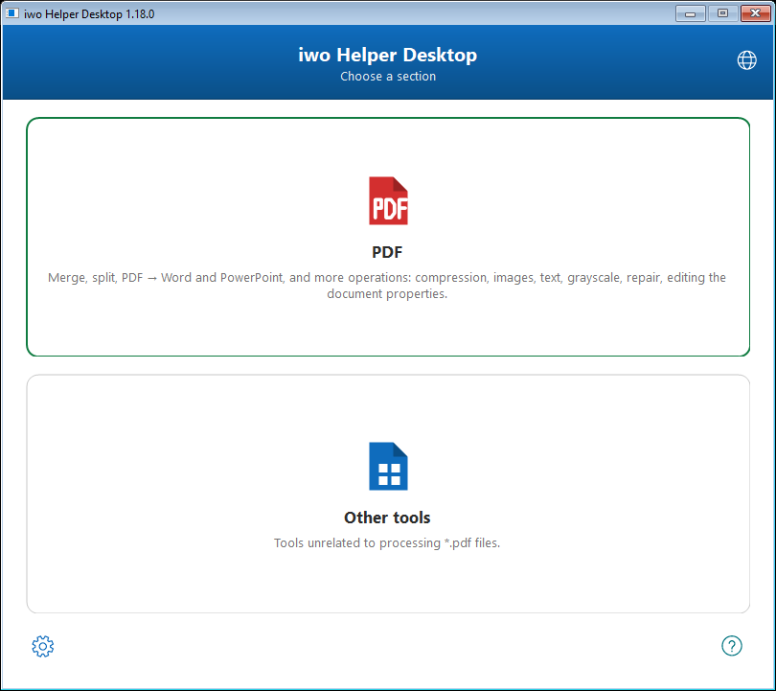
Fig. 1. The start screen: choosing a section
Inside a section are the same cards, one per tool (fig. 2). “Back” on the left of the header, or the Esc key, returns to the sections.
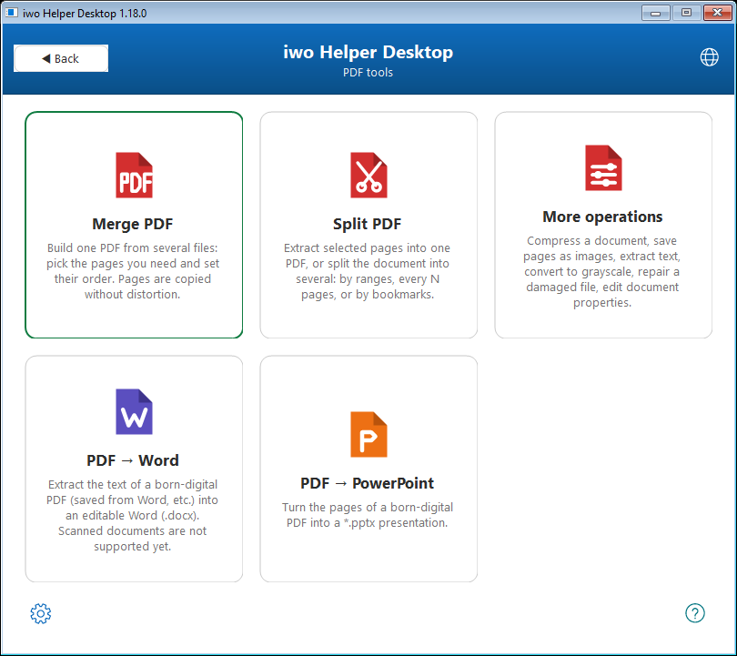
Fig. 2. The “PDF” section: five tools
A card only has to be clicked. A quicker way is to drag PDF files straight onto a card: the tool opens and takes those files at once, skipping the file dialog. Files can also be dropped on the “PDF” section card — the program goes inside and holds them until you pick a tool. The “Merge Excel” card does not accept dropped files, because it works with a folder rather than with separate files.
Two icons sit at the bottom of the window: the gear on the left opens Settings, the question mark on the right opens About. The globe button in the top right corner switches the language. Holding the pointer over an icon shows its name in a tooltip.
Note. The start screen can be closed without closing the tools — they keep working. “Home” on the left of a tool's coloured header brings the screen back, opening the section the tool was started from, so moving to a neighbouring tool is one click, not two.

2.2. The language of the interface
The program speaks Russian and English. The language is chosen with the globe button on the start screen (fig. 3) or with “Язык / Language” in the Menu of any tool.
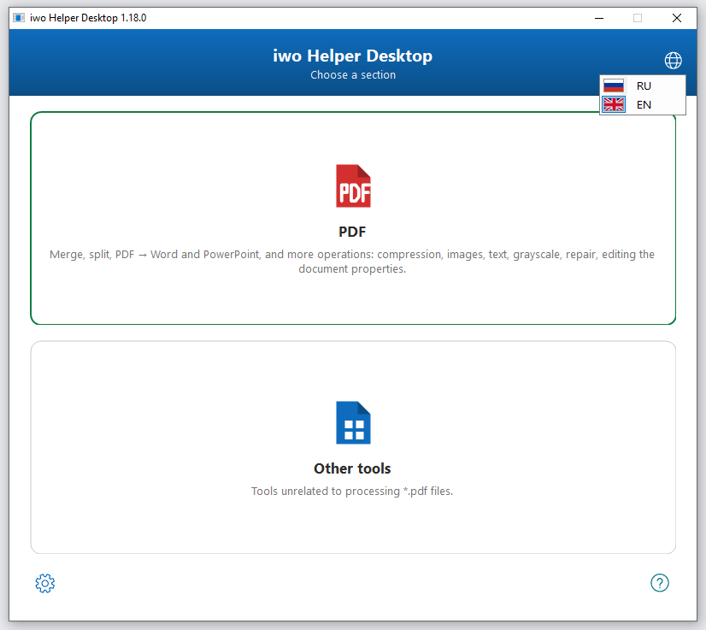
Fig. 3. Choosing the language of the interface
The change takes effect at once: open windows are rebuilt in the new language, staying where they were and keeping the documents they hold. The window you were working in stays active, and minimised windows stay minimised.
Note. The language affects the interface only. The documents the program itself produces — the cover note and the merge report — are always in Russian.

2.3. The built-in help
Every tool has “How to use” in its Menu (the F1 key). It opens a short description of the order of work for that particular window (fig. 4) — the quickest way to recall the sequence without leaving what you are doing.
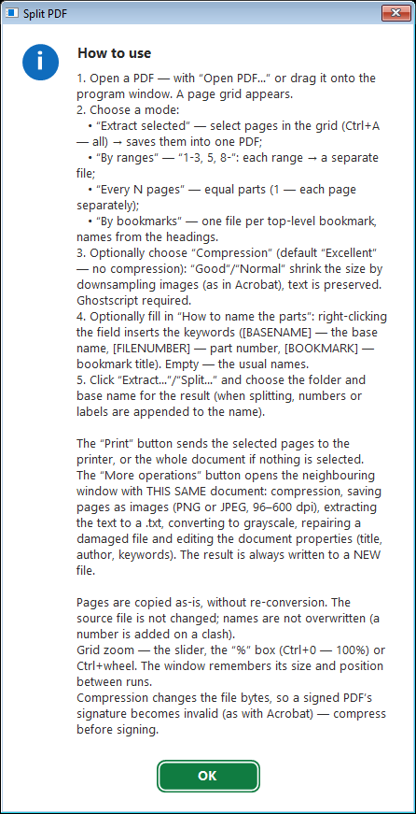
Fig. 4. The built-in help of the “Split PDF” tool
The PDF tools have a second item as well — “Keyboard shortcuts”. It shows a crib sheet for working with the page grid (fig. 5). The set of keys depends on the tool: where the order of pages cannot be changed, those lines are absent.
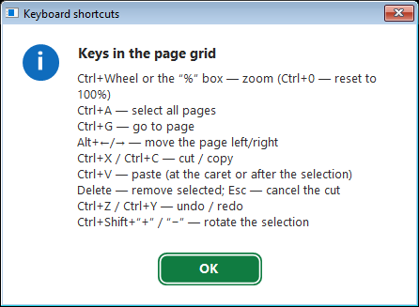
Fig. 5. The crib sheet for working with pages
Table 2 — Keys for working with the page grid
Keys | Action
Ctrl + mouse wheel | Change the thumbnail zoom
Ctrl + 0 | Return the zoom to 100 %
Ctrl + A | Select all pages
Ctrl + G | Go to a page by its number
Alt + ← / Alt + → | Move a page left or right
Ctrl + X / Ctrl + C | Cut or copy the selected pages
Ctrl + V | Paste pages from the clipboard
Delete | Remove the selected pages from the result
Esc | Cancel a cut
Ctrl + Z / Ctrl + Y | Undo or redo the last action
Ctrl + Shift + “+” / “−” | Rotate the selected pages right or left

2.4. The page grid
All the PDF tools are built around the same grid of thumbnails. Learn it once and you can work with every one of them. The only difference is what the grid lets you do: in merging and in the conversions the pages are also reordered, while in splitting and in the other operations they are only selected, because the order does not change there.
Pages are shown as thumbnails in the order in which they will reach the result, with a number under each. They are selected with the mouse, with Ctrl (one at a time) and with Shift (a run). The thumbnail zoom is changed with the slider at the bottom of the window, the “%” box beside it, or Ctrl + mouse wheel. A double click on the “%” box, or Ctrl + 0, returns the natural size.
A right click on a page opens a context menu with every action on the selected pages (fig. 6): the clipboard, moving, rotating, removing and going to a page. The separate items “Select even pages” and “Select odd pages” save time with double-sided scans: one side is selected whole, rather than with fifty clicks.
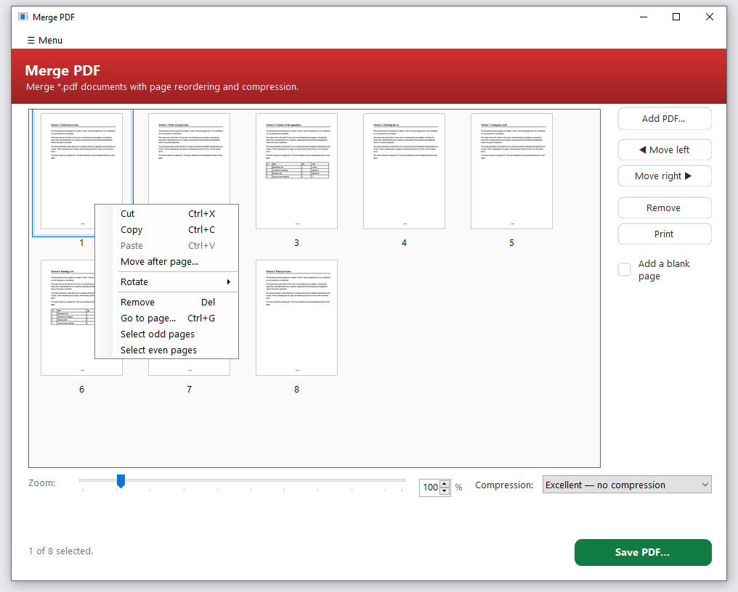
Fig. 6. The context menu of a page in the grid
“Go to page…” (Ctrl + G) is useful in thick documents: instead of scrolling, name the number and the grid scrolls to that page and selects it (fig. 7).
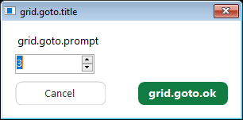
Fig. 7. Going to a page by its number
Any action on the pages is undone with Ctrl + Z and redone with Ctrl + Y — that covers dragging, removing and rotating alike. It is safe to make a mistake.
Note. The order of pages can also be changed by dragging the thumbnails. The insertion point is shown by a vertical bar, so it is hard to miss.

2.5. Viewing a page full size
A double click on a thumbnail opens the page whole (fig. 8). That is how you make sure it is the right page: small type is illegible on a thumbnail.
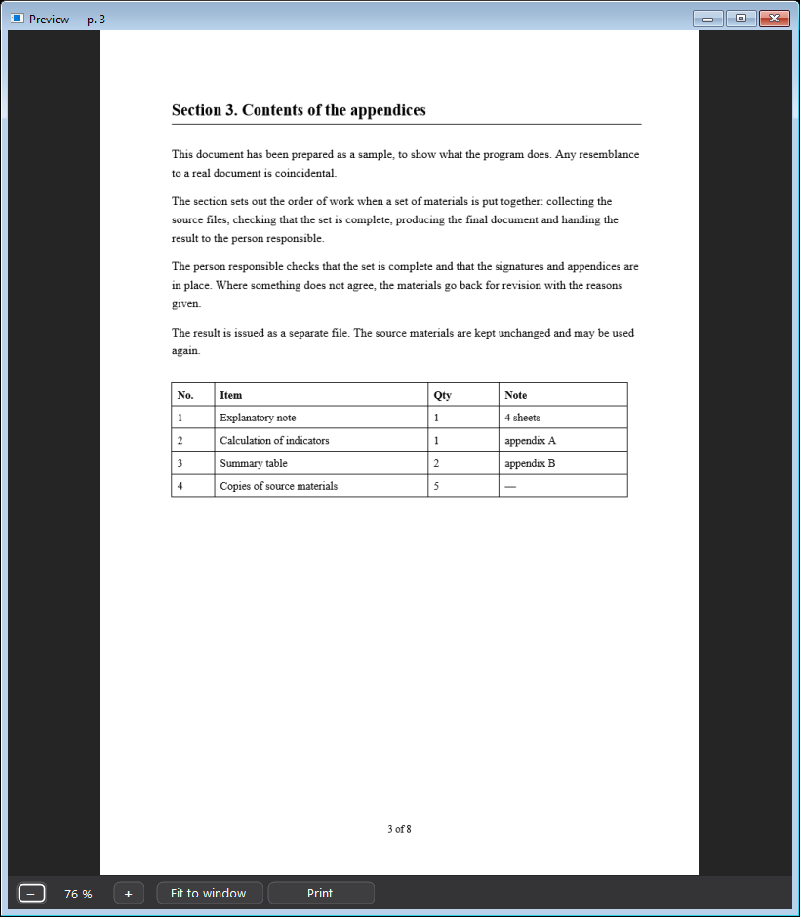
Fig. 8. Viewing a page full size
The viewer has a magnifier: the “−” and “+” buttons, a box with the current zoom, a “Fit” button and Ctrl + mouse wheel. When zooming with the wheel the point under the pointer stays put — what grows is what you are looking at. Once the page no longer fits the window it can be moved with the mouse, “taken by hand”.
A right click offers rotation right and left and a “Print” button. A rotation made here applies to the page in the grid and is undone by the same Ctrl + Z. The viewer minimises to the taskbar like any other window and closes with Esc or the cross.

2.6. Printing
A “Print” button is in merging, splitting, both conversions and the viewer. The rule is one: the selected pages are printed, and if nothing is selected, the whole document. That spares you the usual fiddling with page numbers in the printer dialog — you have already chosen the pages with your eyes in the grid.
The page is fitted to the sheet whole, centred and in proportion. Stretching it to the edges would cut off the margins, which is where signatures and page numbers usually are. A rotation set in the grid reaches the paper too.

2.7. Making the file smaller (compression)
Compression is offered wherever the output is a PDF — in merging, splitting and the other operations: the “Compression” list is on the bottom line of the window (fig. 9). It applies to the resulting file; the source is untouched.
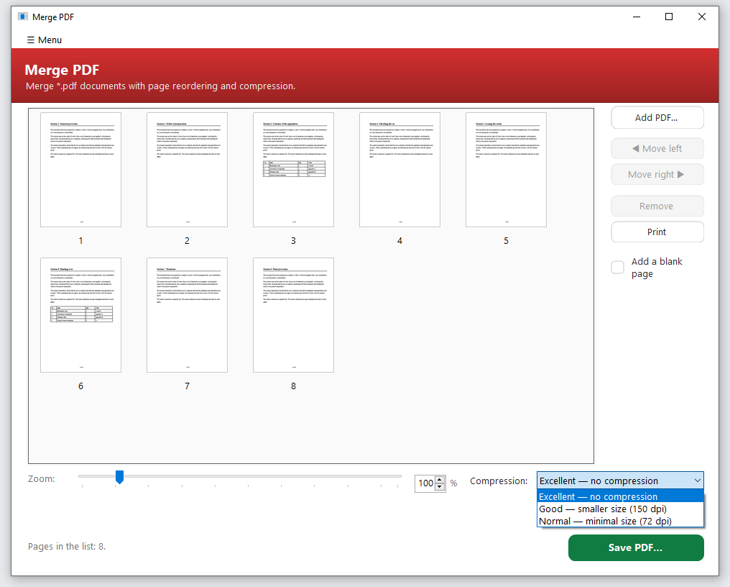
Fig. 9. Choosing the level of compression
The size goes down because the resolution of the pictures inside the document goes down — the same way Adobe Acrobat works. Text and vector graphics are left alone and lose no sharpness, which is why a document typed in Word gains almost nothing from compression while a scanned one gains many times over.
Table 3 — Levels of compression
Level | What it does | When to choose it
Excellent — no compression | The file is saved as it is | The default. When every detail of the image matters
Good — smaller size (150 dpi) | Pictures are brought down to 150 dots per inch | Sending by mail, publishing. Text on a scan stays legible
Normal — minimal size (72 dpi) | Pictures are brought down to 72 dots per inch | When only the content has to arrive and the size is critical

How much that is worth is shown by a measurement on a scanned document of four pages (fig. 10). The source file took 8.97 MB, after “Good” — 0.68 MB, after “Normal” — 0.24 MB.
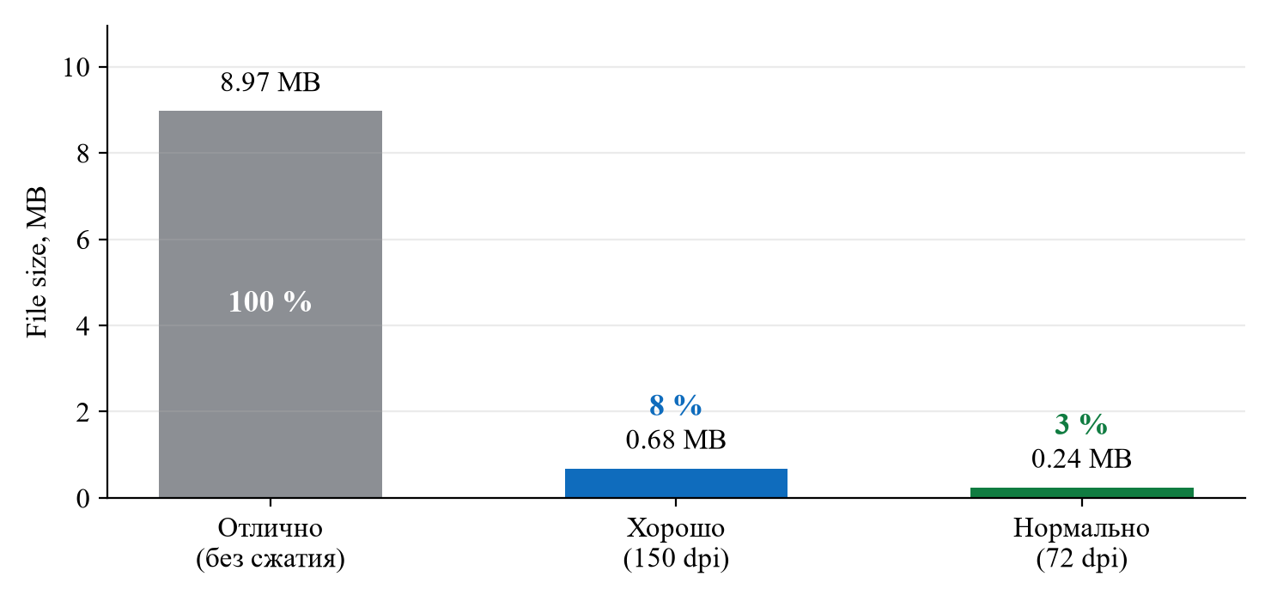
Fig. 10. The size of a scanned document at different levels of compression
Compression changes the contents of the file, so a digital signature on the document becomes invalid. Compress before signing, not after.

2.8. Settings
The gear at the bottom of the start screen opens Settings — what belongs to the whole program rather than to an open document (fig. 11). The same item is in the Menu of every tool.
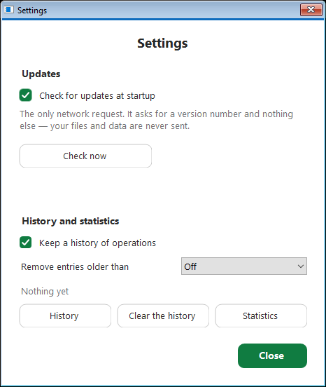
Fig. 11. The settings of the program
“Check for updates at startup” is the only request the program makes to the network. Only a request for the latest version number is sent; no files and no data of yours are ever sent. The check can be switched off entirely, and the “Check now” button asks on demand.
“Keep a history of operations” switches on a log: what exactly the program did, when, and which file came out. It exists so that yesterday's result can be found without recalling where it was saved: the “History” button opens the list, and from there the file itself or its folder. The “Remove entries older than” list sets how long entries live; “Clear history” erases them at once.
Note. The history keeps only file names, paths and the time of the operation — not the contents — and it lives on your computer. A history switched off is not written at all.
The compression level and the thumbnail zoom are deliberately left out of Settings: they are changed while working, and walking to a separate window for each file would take longer than the work itself.

2.9. Statistics
“Statistics” in the Menu shows how many operations of each kind have been done (fig. 12). It is a simple way to see how much manual work the program has already taken away.
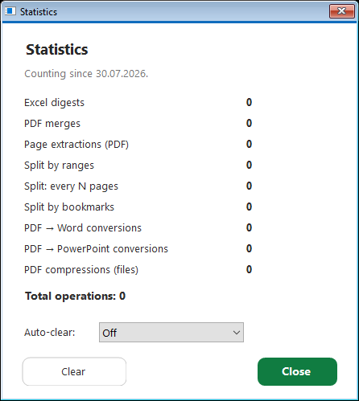
Fig. 12. The counters of completed operations
The counters can be reset with “Clear”, or set to reset themselves once a day, a week or a month. The data is kept on your computer only.

2.10. What happens to your files
The program does not send documents anywhere, does not keep copies of them and does not log their contents. All it writes is window settings, operation counters and reports on merging Excel workbooks. A report holds the names of files and sheets, not what is in them.
The result of any operation is always a new file. If you name as the result the same file that is open in the program, the operation is refused with a plain message: writing a file into itself would destroy it.

3. Merge PDF

3.1. What it is for
The tool builds one PDF out of several files and individual pages. Unlike plain “gluing”, here every page is visible and can be moved, rotated or thrown out before the file is written.
Its main property is that pages are copied as they are, without being converted again. A scan stays the same scan; stamps and signatures do not drift. That is why merging is safe for documents that will travel further up the chain.

3.2. The window
On the left is the grid of pages of all the added files, on the right the actions on them, at the bottom the zoom, the compression and the save button (fig. 13).
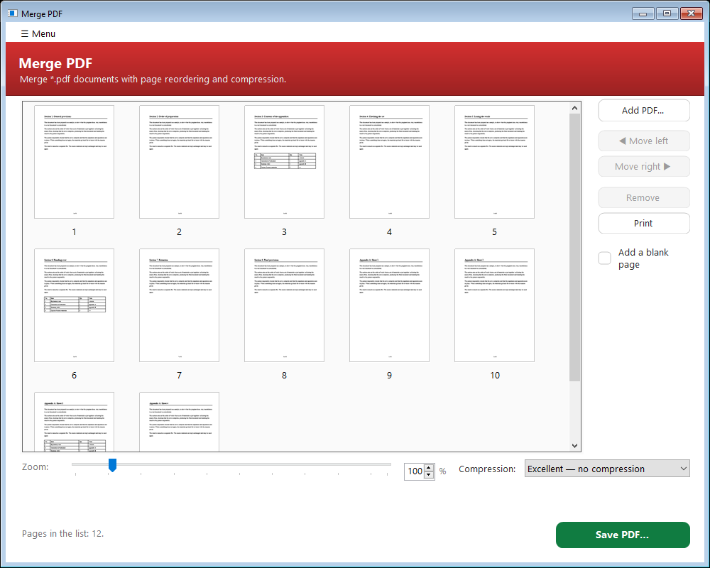
Fig. 13. The “Merge PDF” window

3.3. The order of work
1. Add the files with “Add PDF…” or drag them into the window. There may be any number of files; the pages of all of them line up in one grid.
2. Set the order of the pages by dragging the thumbnails or with the “◀ Move left” and “Move right ▶” buttons. Remove pages you do not need with “Remove” or the Delete key.
3. Choose the level of compression if the resulting file has to be smaller (see 2.7).
4. Press “Save PDF…” and give the file a name. The program offers a default name and the folder of the first added document.

3.4. Double-sided printing: “Add a blank page”
The “Add a blank page” tick box on the right is for a merged document that will be printed on both sides of the sheet. If a document has an odd number of pages, the next one starts on the back of the previous one — the program puts a blank page between them so that each document starts on the front of a sheet.
Note. No blank page is added after the last document: nothing is printed after it anyway. Blank pages appear only in the written file and do not clutter the grid.

3.5. Assembling a double-sided scan
“Assemble a double-sided scan (front + back)” in the Menu solves a common trouble with single-sided scanners (fig. 14). The stack is scanned face up, turned over and scanned again — which gives two files, the second of them usually in reverse order.
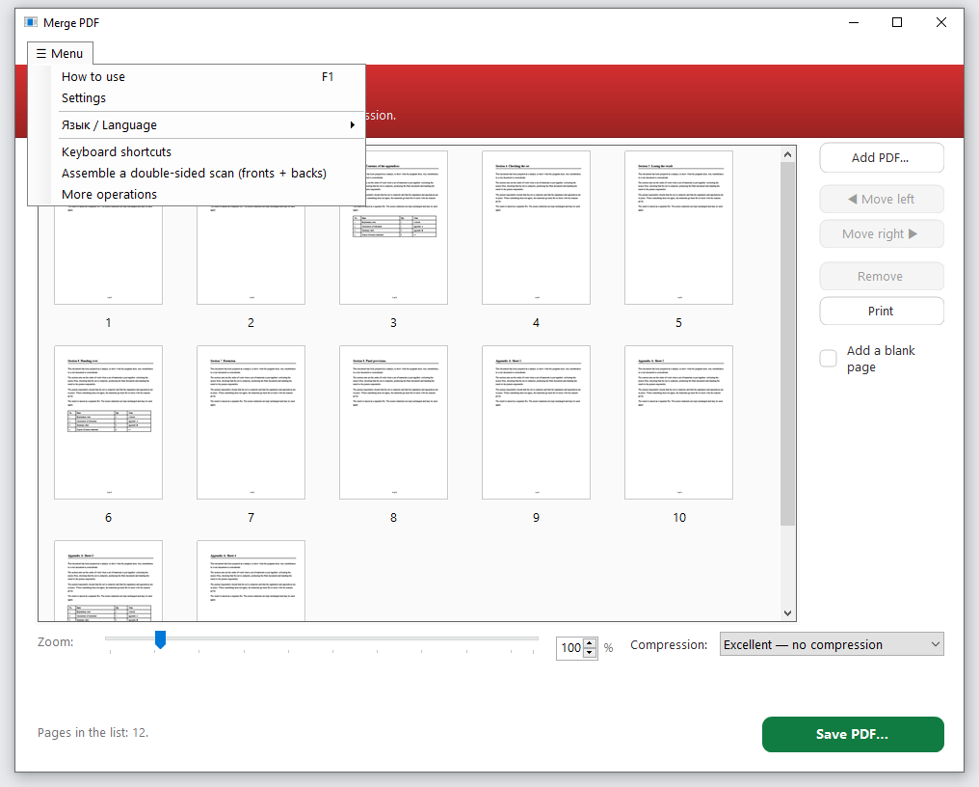
Fig. 14. The Menu of the “Merge PDF” tool
Add both files and choose that item. The program asks whether the second document came out back to front and lays the pages out in turn: 1, 2, 3, 4… One Ctrl + Z brings the previous order back if something went wrong.

4. Split PDF

4.1. What it is for
The tool solves two related tasks: taking the pages you need out of a document, and cutting a document into parts. Beyond that, the extra actions on an open file live here — saving pages as images, extracting text, converting to grayscale, repairing a damaged file and editing the document properties.
Its value is that the recipient gets exactly what is addressed to them. Not “a volume of three hundred pages, see section four”, but section four as a file of its own.

4.2. The window
On the left is the grid of pages of the open document, on the right the choice of mode and its settings (fig. 15). The set of fields on the right changes with the mode, so nothing superfluous is on screen.
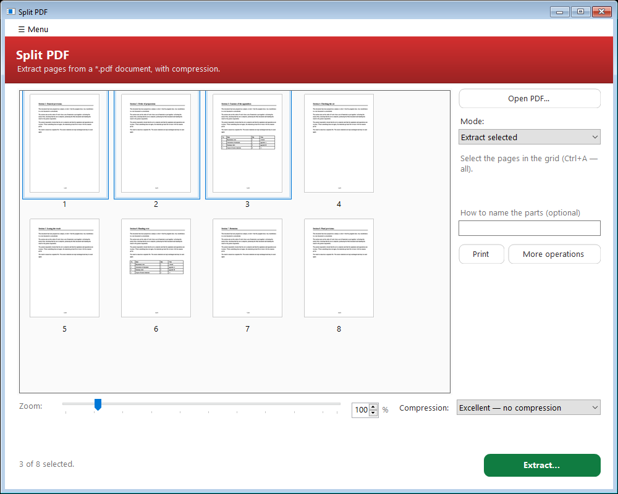
Fig. 15. The “Split PDF” window

4.3. The modes of splitting
The mode is chosen in the “Mode” list (fig. 16). Under the list the program says briefly what the chosen mode will do, and the caption on the big button changes from “Extract…” to “Split…” — so that what will happen is clear before it does.
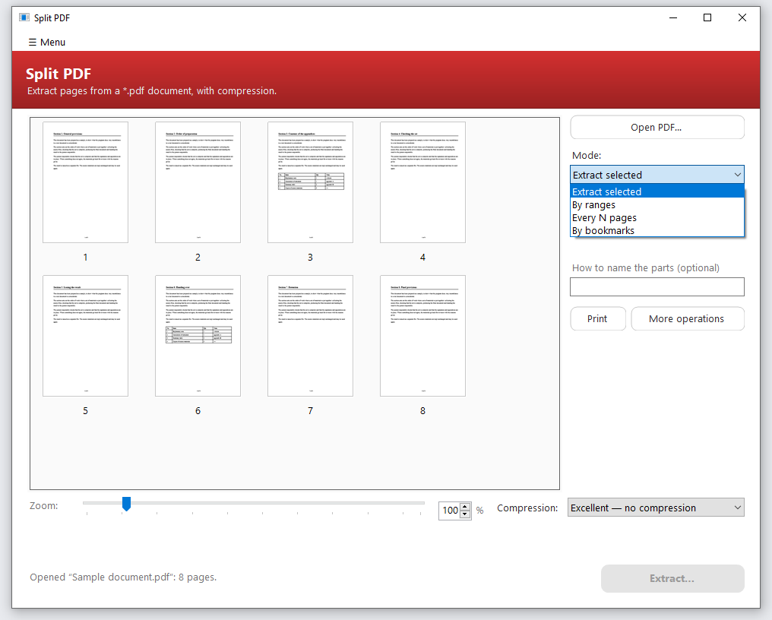
Fig. 16. Choosing the mode of splitting
Table 4 — The modes of splitting
Mode | What comes out | When it suits
Extract selected | One file from the pages selected in the grid | Particular pages are needed and are easier to pick by eye
By ranges | A file per range, or one common file | The page numbers are known in advance
Every N pages | Files of equal size, N pages each | The document has to be broken into equal parts
By bookmarks | A file per top-level bookmark | The document has bookmarks: the sections separate themselves

“By ranges” takes numbers and ranges — “1-3, 5, 8-” (fig. 17). By default every range becomes a separate file, and the “Combine into one file” tick box gathers all the listed pages into a single document.
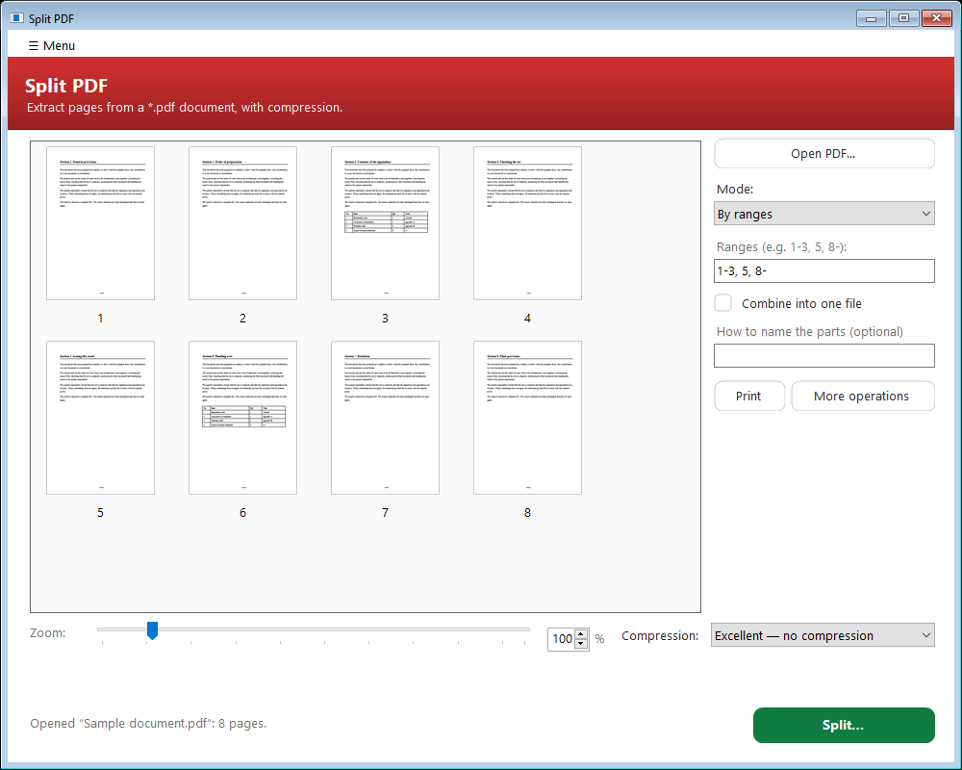
Fig. 17. The “By ranges” mode
“Every N pages” cuts the document into parts of the given size (fig. 18). A value of 1 means “every page as its own file”.
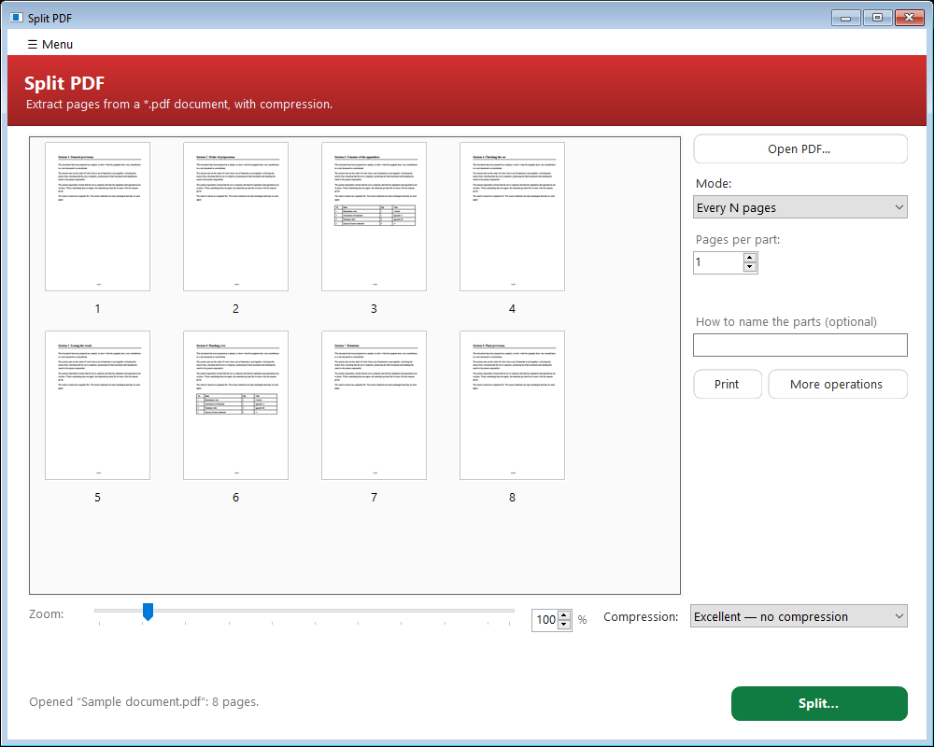
Fig. 18. The “Every N pages” mode
“By bookmarks” relies on the table of contents inside the PDF: every top-level bookmark gives a separate file, and its name goes into the file name (fig. 19). If the document has no bookmarks, the program says so and writes nothing.
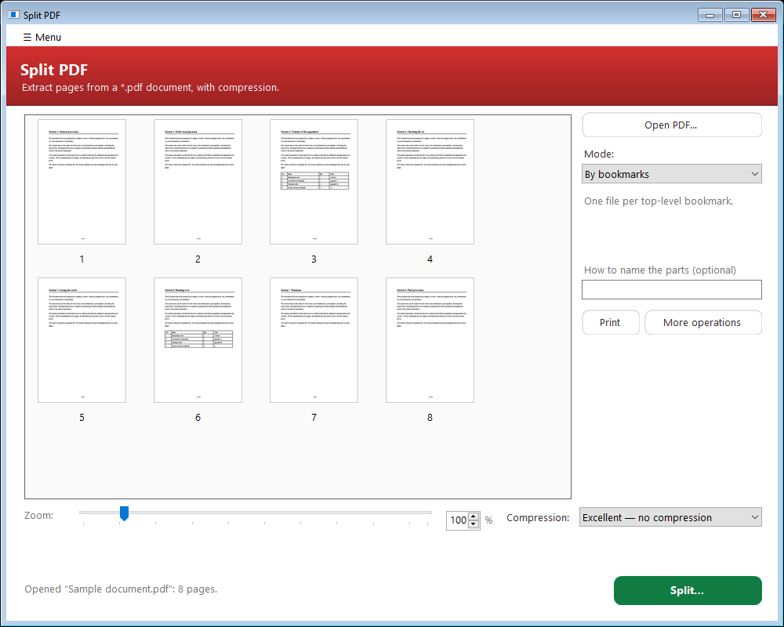
Fig. 19. The “By bookmarks” mode

4.4. Naming the parts
The “How to name the parts” field sets how the names of the resulting files are built from the base name. The field is optional: left empty, the parts get the same names as before — the base name plus a number or a range.
A right click on the field inserts the available placeholders (fig. 20). The folder and the base name you will give later, in the ordinary save dialog.
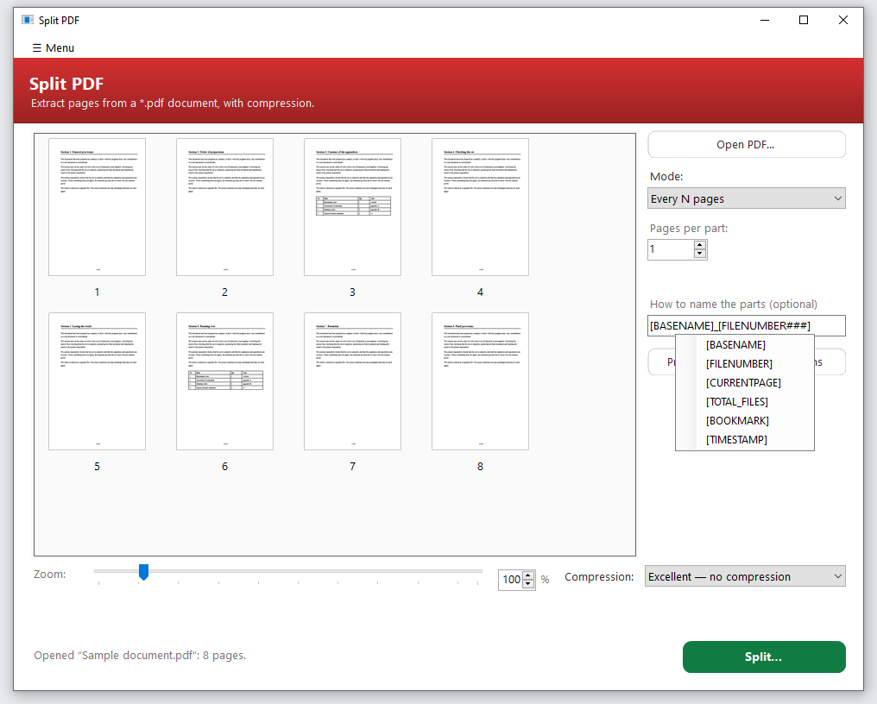
Fig. 20. Inserting placeholders into the name template
Table 5 — Placeholders in the name template
Placeholder | What is substituted | Example
[BASENAME] | The base name from the save dialog | Contract
[FILENUMBER] | The number of the part in order | 1, 2, 3
[FILENUMBER###] | The same number with leading zeros | 001, 002, 003
[FILENUMBER10] | Numbering with an offset | 11, 12, 13
[CURRENTPAGE] | The first page of the part in the source document | 5
[TOTAL_FILES] | How many parts came out in all | 20
[BOOKMARK] | The name of the bookmark (in “By bookmarks”) | Section 1
[TIMESTAMP] | The date and time of the operation | 2026-07-27_10-45-03

Placeholders can be mixed with ordinary text. The template “[BASENAME]_part_[FILENUMBER###]”, for instance, gives “Contract_part_001”, “Contract_part_002” and so on — which sort correctly in the file manager even at a hundred parts.
Note. Characters that a file name may not contain are replaced automatically, and long bookmark names are shortened. It is not possible to write a file with a name Windows would refuse.

4.5. Other operations on the open document
The “More operations” button on the right opens the tool of that name (section 5) and hands it the document open here. There is no need to open the file again: compressing it, converting it to grayscale, saving its pages as images, extracting its text or editing its properties can be done at once, without leaving the work you started.

5. More operations

5.1. What it is for
The tool gathers six actions on ONE document — those that are neither merging nor splitting, but are needed all the time: make it smaller, take the colour out, repair a damaged file, pull pages out of it as images or as text, edit its properties.
All six write a new file and leave the source alone, so they are safe to try: if you do not like the result, you still have the original.

5.2. The window
On the left is the grid of pages of the open document, on the right the buttons, grouped by meaning: “Convert the document”, “Extract from the document” and “Edit” (fig. 21).
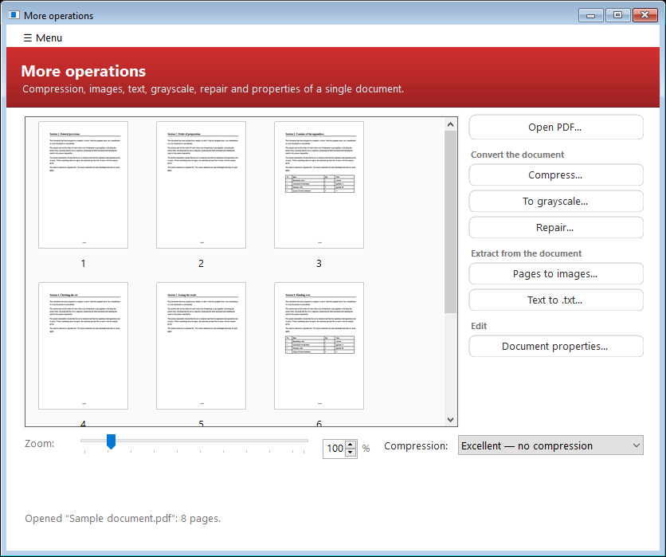
Fig. 21. The “More operations” window
A document reaches this window three ways: with the “Open PDF…” button, by being dragged into the window, and by coming across from a neighbouring tool — “Split PDF” hands over its open document with its own “More operations” button, and “Merge PDF” hands over the file it has just built through “More operations” in its Menu.
Note. Until a document is open the action buttons are greyed out: it is immediately clear that a file is needed first, and there is no need to find that out by clicking.

5.3. The actions
— Compress. Makes a finished file smaller — with the same levels as merging (see 2.7). If the file is already optimised, the program says so rather than silently handing back the same file.
— To grayscale. A colour document becomes black and white. That makes the file noticeably smaller and printing on a monochrome printer predictable.
— Repair. The file is rebuilt by the PDF engine, which repairs a broken cross-reference table — the commonest cause of the message “the file is damaged”. The file is chosen in a separate dialog, because a damaged document cannot be opened into the grid — and that is exactly when repair is needed.
— Pages as images. PNG or JPEG with a choice of resolution (fig. 22). Needed when a page has to go into a presentation, a letter or a memo. The resolution applies to the real size of the sheet, so a landscape insertion is not stretched. The selected pages are saved, or all of them if nothing is selected.
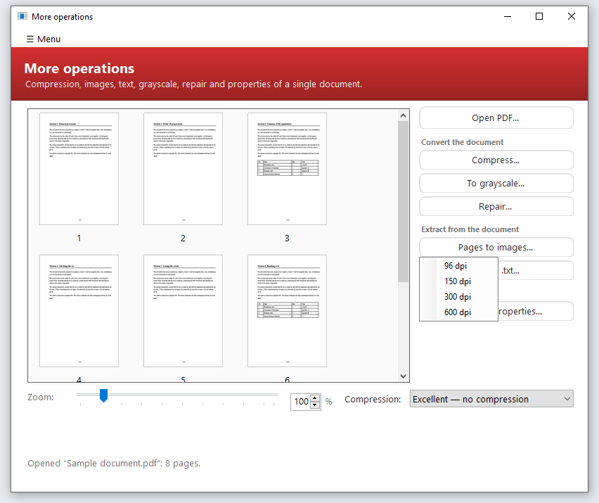
Fig. 22. Choosing the resolution when saving pages as images
— Text into .txt. The text layer of the document is saved into a .txt file. Tables are not lost: cells are separated by tabs and paste into Excel as a table. Pages are separated by a page-break character, and the file is written in UTF-8.
— Document properties. Title, author, subject and keywords — what any viewer shows in the properties of a file (fig. 23). An empty field clears the property: that is how an author's name is taken out of a document before it is sent.
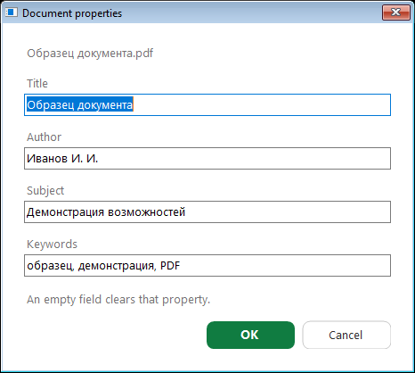
Fig. 23. Editing the properties of a document
Note. Compression, conversion to grayscale and repair are done by the Ghostscript engine. In the installed version it is already there; for the portable one the program offers a link to download it.

6. PDF → Word (beta)

6.1. What it is for
The tool extracts the text and tables of a born-digital PDF into an editable Word document (.docx). Born-digital means saved from Word, from a browser or through “Microsoft Print to PDF”: in such a file the text is held as text, not as a picture.
The point is simple: text somebody has already typed does not have to be typed again. From the resulting .docx you can take a paragraph, a table or the whole document and work with it as usual.

6.2. The window
The window is arranged like “Merge PDF”: on the left the grid of pages of all the added files, on the right the actions, at the bottom the zoom and the “Convert to Word…” button (fig. 24).
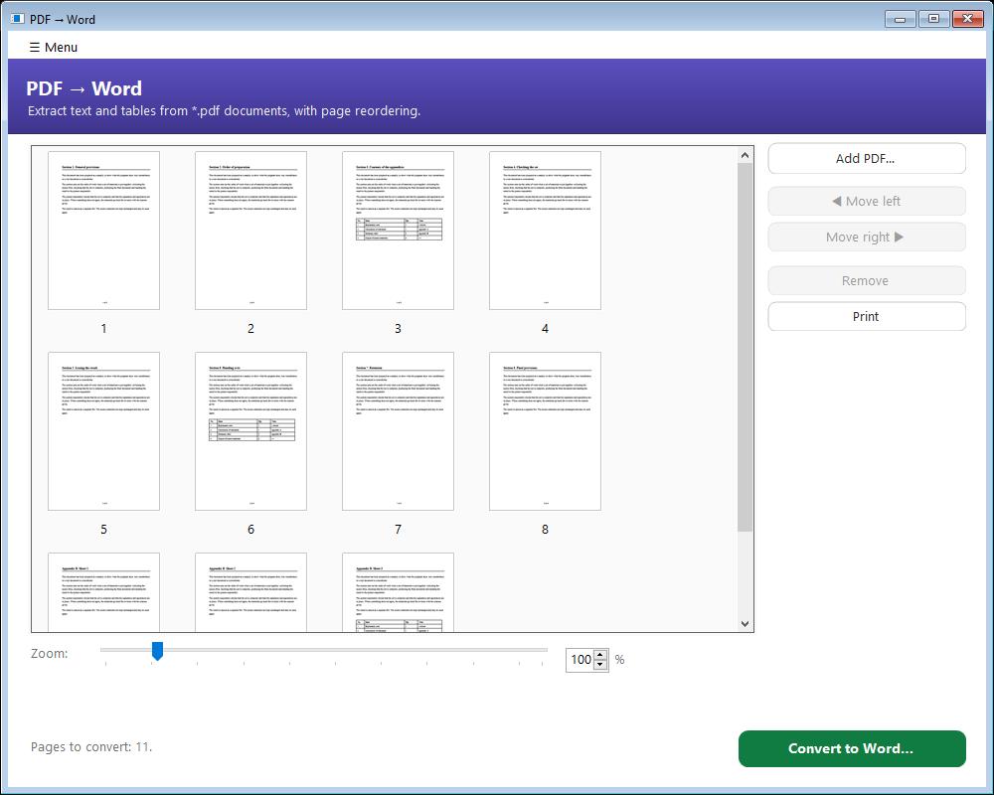
Fig. 24. The “PDF → Word” window

6.3. The order of work
1. Add one or more PDFs with “Add PDF…” or drag them into the window. The pages of all the files are shown in one grid, so one Word document can be assembled from several PDFs.
2. Change the order of the pages if you need to by dragging the thumbnails or with the “◀ Move left” and “Move right ▶” buttons. Remove pages you do not need with “Remove”. The pages reach Word in exactly the order shown.
3. Straighten rotated pages. If a page lies on its side, turn it before converting: the layout is analysed in the position you see, and sideways text will not become lines otherwise.
4. Press “Convert to Word…” and give the file a name. When it is done the document opens by itself.

6.4. What comes across and what does not
What comes across: text in paragraphs in reading order — with its font, size, weight, colour, underline, alignment and first-line indent. Tables with visible lines are rebuilt as cells, merged ones included. Portrait and landscape orientation is kept page by page. Images and hyperlinks come across too.
The limits are worth knowing in advance, so as not to waste time.
— Scanned documents are not supported — pages that are images with no text layer. The program says so, and the file is not harmed.
— If the font of the PDF is not in the system, the text is set in Times New Roman. The shape of the letters may differ a little from the original.
— Tables without lines, boxed insets and text in several columns come across as plain paragraphs in one column — they may have to be tidied by hand.
One rare case is worth mentioning separately: if the PDF was saved with a broken text encoding, what is extracted will be unreadable. That is a defect of the file itself, not of the conversion.

7. PDF → PowerPoint (beta)

7.1. What it is for
The tool turns the pages of a born-digital PDF into a PowerPoint presentation (.pptx). Every page becomes a slide, and the text on it stays TEXT: it can be selected, corrected, retyped — it is not a picture of letters.
The situation this exists for comes up constantly: the presentation went to its recipient as a PDF, the source file is lost, and it has to be edited. The usual way is to retype the slides; this tool brings them back in one action.
PowerPoint itself is not needed for it: the program assembles the .pptx on its own. The tool is used precisely when there is no office suite at hand, and requiring one to be installed in order to put text into slides would be odd.

7.2. How a slide is built
A slide is made of two layers. The lower one is the page of the source PDF, rendered WITHOUT its text layer: background, frames, charts, logos, stamps. The upper one is the text boxes, placed exactly where the text stood in the original.
That division was not chosen out of laziness. On an ordinary slide most of the image is not text, and a text-only conversion would leave a dozen labels on a white sheet. A whole-page-as-a-picture conversion would give a handsome but dead slide in which not a letter could be corrected. Two layers give both the look and the editing.
Note. The background is rendered by Ghostscript. Without it the presentation is assembled from the text and the images alone — silently, without an error: it is still a working file, only without the background.

7.3. The window
The window is the same as “PDF → Word”: on the left the grid of pages, on the right the actions, at the bottom the zoom and the “Convert to PowerPoint…” button (fig. 25). Every habit of the grid — selecting, ordering, rotating, previewing, undoing — works the same.
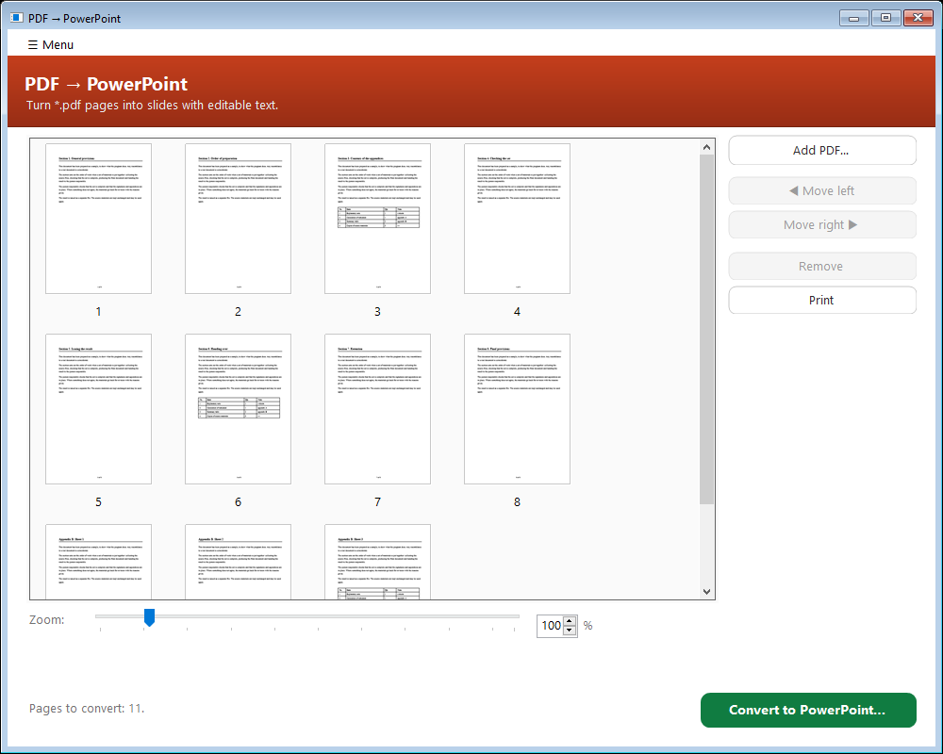
Fig. 25. The “PDF → PowerPoint” window

7.4. The order of work
1. Add PDFs with “Add PDF…” or drag them into the window. The pages of several files are gathered into one presentation.
2. Arrange the pages by dragging or with the “◀ Move left” and “Move right ▶” buttons; remove the ones you do not need with “Remove”. The slides follow exactly the order shown.
3. Check the orientation. Straighten a rotated page before converting — the layout is read in the position you see.
4. Press “Convert to PowerPoint…” and give the file a name. The finished presentation opens by itself.

7.5. What comes across
Text comes across in paragraphs, with its font, size, weight, colour, underline, super- and subscripts and hyperlinks. Tables become real slide tables, merged cells included. The slide size follows the page: a 16:9 deck stays 16:9, and an A4 document gives A4 slides.
The boundaries of the paragraphs are taken from the file itself where it carries them: a PDF saved from Word, PowerPoint or Acrobat holds the structure of the document, and in it the author has already marked where one paragraph ends and the next begins. Then a paragraph arrives as one text box and is edited as a whole. Where there is no such structure, the boundaries are recovered from the distances between the lines.

7.6. What not to expect
— There will be no text where the source has none — pages saved as a picture in their entirety. Such slides arrive as a background without a single letter, and the program says honestly how many there were: only recognition can bring the text back from those.
— What is not in the PDF does not come across: animation, transitions, speaker notes and the links from charts to their source data are not kept at all — there is nowhere to take them from.
— Small differences in setting are possible: lines justified by stretching the spaces arrive with ordinary spaces: reproducing the stretch would mean laying the line out in fragments, and then the paragraph would stop being editable as a whole.

8. Merge Excel

8.1. What it is for
The tool gathers the sheets of several Excel workbooks into one workbook — a digest. The typical task: the divisions have each sent a file, and what is wanted is one document where each file is a separate sheet, there are contents with links, and it is clear which files could not be processed and why.
Assembling such a digest by hand means opening every workbook, copying a sheet, pasting it, renaming it, and round again. The program does it in one pass, keeping the formatting, the formulas and the charts.

8.2. The window
The window is divided into blocks by meaning: where to take from, where to save, with what options and what exactly to merge (fig. 26).
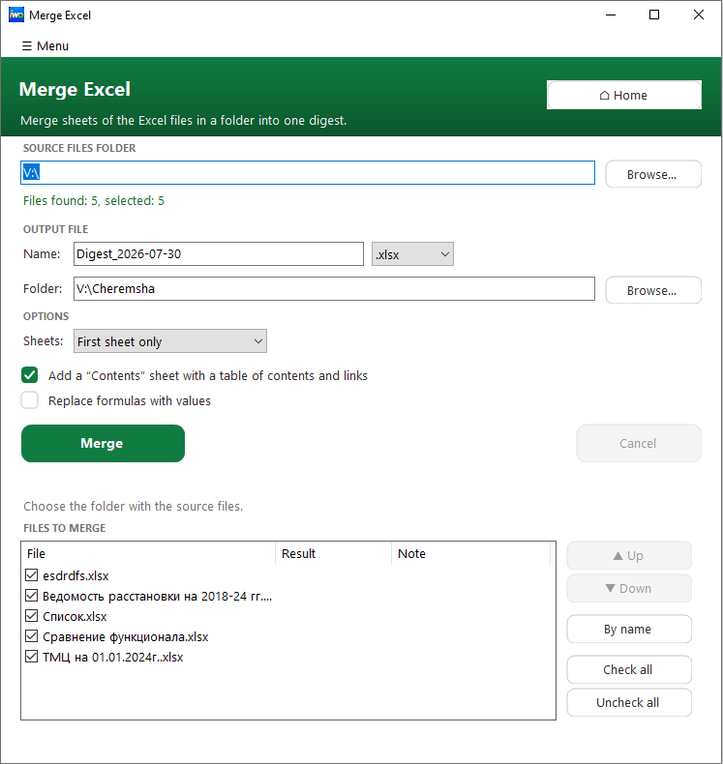
Fig. 26. The “Merge Excel” window

8.3. The order of work
1. Give the folder of the source files with “Browse…” or drag it straight into the window. The program counts the files found at once and shows them in the list below.
2. Give the resulting file a name. The extension is added automatically, so there is no need to type it. The “.xls” format is left for those who need Excel 97–2003. If the “Folder” field is left empty, the digest is put beside the source files.
3. Check the contents and the order in “Files to merge”. The order is set by dragging the rows or with the “▲ Up” and “▼ Down” buttons; “By name” restores the natural order. A file is excluded by clearing its tick, and “Check all” and “Uncheck all” do it wholesale.
4. Press “Merge”. Progress is shown in the status line and the progress bar, and “Cancel” stops the run after the current file.

8.4. The options
— Sheets. “First sheet only” takes the first visible sheet of each workbook — the usual case when a file holds a single form. “All sheets” moves every visible sheet.
— The “Contents” sheet. The first sheet of the digest becomes its contents: the names of the files, hyperlinks to the corresponding sheets and the status of each file. The digest becomes something to move around in, rather than fifty tabs to search through.
— Replace formulas with values. Calculated values reach the digest instead of formulas. The digest stops depending on the source workbooks: it can be sent on, and its numbers will not drift or turn into errors for want of a reference.

8.5. The result, the report and the cover note
After the run the outcome for each file appears in the list itself — in the “Result” and “Note” columns. Broken and password-protected workbooks are skipped with the reason given, and the rest are moved across. Links appear at the bottom of the window: open the finished file, open its folder, open the merge report.
“Retry skipped” adds the corrected files into the digest already assembled, without rebuilding it whole. That saves time when two files out of thirty failed.
“Word note” produces a cover note for the digest as a .docx: the totals, the list of skipped files and standard formatting. The note only has to be signed, not written from nothing.

8.6. The Menu of the tool
The Menu holds the built-in help, the statistics, the choice of language and “Reports folder”, which opens the folder with the most recent merge reports (fig. 27).
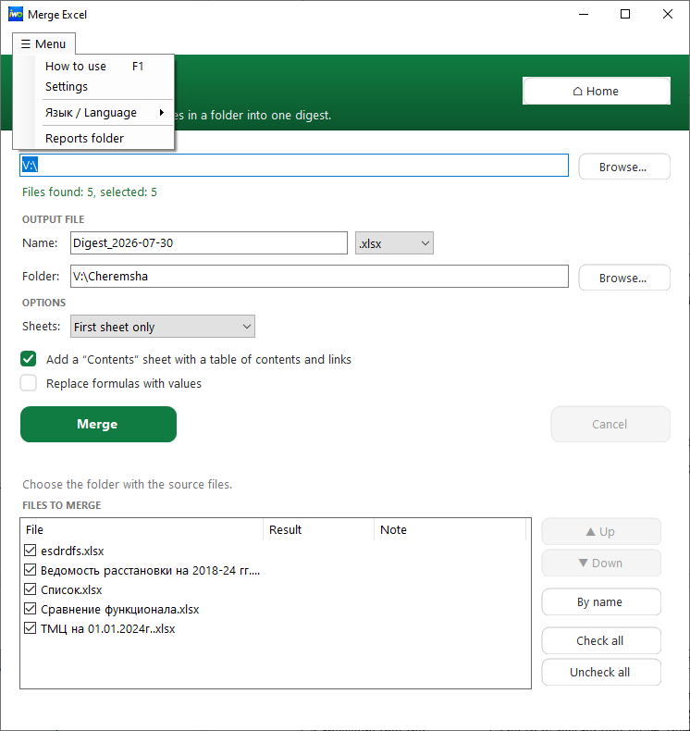
Fig. 27. The Menu of the “Merge Excel” tool
Note. The usual keys work in the file list: Alt + ↑ and Alt + ↓ change the order, Delete excludes a file, Ctrl + A selects everything, Ctrl + C copies the rows to the clipboard.

9. Reference

9.1. About the program
The About window is opened by the button on the start screen (fig. 28). It gives the version, the author, links to the project page and to the privacy policy, and the licence.
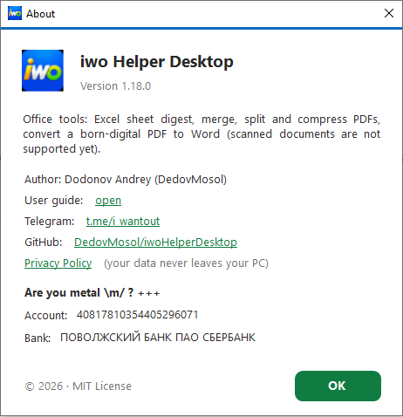
Fig. 28. The About window
The version number is useful when asking for help: it says at once which build is meant. The details for supporting the project voluntarily can be selected and copied as ordinary text.
The line “User manual: open” opens this document. It lives inside the program itself, so it is available both in the portable version and without the internet: at the first request the program unpacks it beside its settings and opens it.

9.2. If something went wrong
The program tries to explain failures in words rather than in error codes. Below are the situations that come up more often than others.
Table 6 — Common difficulties and what to do
What you see | What it means and what to do
The message “Ghostscript is needed” when choosing compression | The compression engine is not installed. The window has a link to download it, and in the installed version of the program it is put in place at once
A file was skipped while building the digest | The workbook is damaged or password-protected. The reason is in the “Note” column and in the report. Fix the file and press “Retry skipped”
A message that the document is scanned | The PDF has no text layer, there is nothing to convert. The file is not damaged
The text after conversion to Word is unreadable | The source PDF has a broken encoding. Check whether the text copies out of the PDF itself: if it does not, the defect is in the source file
The program refuses to save the result | You named the same file that is open in the program, or a folder there is no right to write to. Choose another name or another folder
A signature in the PDF became invalid | The document was compressed or rebuilt after it was signed. Sign the finished file as the last action
The window does not appear when the program is started again | The program is already running: it brings the existing window to the front instead of opening a second one
“Repair” or “To grayscale” answer with a refusal | The document is password-protected: the engine cannot read it. Remove the protection in the program that applied it and try again
The download page did not open after the message about a new version | There is no default browser in the system. The program shows the address itself — it can be typed by hand

9.3. A short reminder
Three rules that answer most of the questions.
— The program never changes the source files. The result is always a new file.
— Anything done to the pages is undone with Ctrl + Z.
— If it is not clear what a button does, hold the pointer over it: the tooltip explains what it is for and names the shortcut.

The program does not go to the internet for any operation on a document. Its only network request is the check for a newer version, which can be switched off in Settings.
Ghostscript is part of the installer and is installed together with the program. For the portable version it has to be installed separately — the program offers the link the first time compression is needed.
Settings, merge reports and the statistics counters are kept in the user profile and carry over between versions — reinstalling does not erase them.
This is a property of any PDF compression, not a quirk of this program: a signature certifies particular bytes, and rebuilding the file changes them.
The program will not let the result be written over the open document: such a write would destroy the file the operation itself is reading.
It is easy to check: open the PDF in any viewer, select the text and copy it (Ctrl + C). If nonsense lands in the clipboard, the text layer of the document was broken to begin with.
A .pptx file is a set of XML files in an archive, described by an open standard. The program writes them directly.
Merge reports are kept in the user profile; the three most recent remain. Their folder can be opened through Menu → “Reports folder”.
The file is unpacked into the user profile, beside the settings of the program. It may be deleted — it will appear again at the next request.

